# Overview

**Android Performance Evaluator** is a service that allows developers to check how efficiently their application is running on the android OS.

This product is not complete.All of the wording will need to be revised several times before it is finalized. The graphics and layout of the screens is shown here are not the final product. The actual look and feel will be developed over time with different input from product managers and programmers.

# Installation Instructions

# A brief high level “how-to-use” guide for the current build.

*Last revised 4/20/2016*

Prerequisite: You must have Gradle 2.2 installed in order to build the APK. Gradle installation instructions are included on page 2.

1. Start the Java app. Log in or create a new user.
2. Select the source code you wish to parse or the apk you wish to analyze from the file explorer. Select the entire package if passing in source code - DO NOT navigate to the /src folder or any other subdirectory. The parser needs to the entire project structure to generate the parsed output.
3. Select the directory containing the jar files needed to compile the application. These will be added to the classpath in order to fully analyze the application.
4. Select the directory containing your android sdks.
5. Select the directory containing the emulator adb.
6. Start the emulator.
7. Select *Parse*. Parser will parse through your uploaded code (and decompile it if necessary). While parsing, you will be informed of any methods Parser was unable to analyze, likely due to missing jar files. When Parser has completed analyzing the source code, it will produce an output file that ModuleBuilder will use in order to generate your Xposed module.
8. After ModuleBuilder has created the base java file, APKBuilder will bundle the necessary components into an APK and automatically install it onto your connected Android device or emulator. Ensure that your Android device or emulator is on and connected.
9. Once the module is installed, restart your phone or emulator to complete the installation. You are now ready to analyze the app.
10. Use the app. The logcat will keep a record of the called methods.
11. When you are finished using the app, select *Send* *Data* to stop execution. Select *Send Data* again to push the data to the database.
12. The data is now available on the webapp.
13. Log onto <http://localhost/softDev/index.php>. Enter the appropriate user name and password.
14. Select Projects and then the app you wish to analyze. Charts will appear with your uploaded data. Select Make CSV or Make PDF to get the stats as raw data.

Gradle 2.2 Installation Instructions

Gradle version 2.2 is required to build the APK.

1. Navigate to <http://gradle.org/gradle-download/>. Scroll to *Previous Releases* located at the bottom right and select *Choose Version*.
2. Select version 2.2 and *Complete distribution*.
3. Save the download in an appropriate directory (ideally home directory).
4. Add environment variable “GRADLE_HOME”. Point it to the downloaded files.
5. Add “GRADLE_HOME/bin” to PATH environment variable.
6. Test by running “gradle” in the terminal.

# Data Flow

Below is the data flow of the program and should give a general sense of how to use the Android Performance Evaluator. Details of each component will be described in detail later.

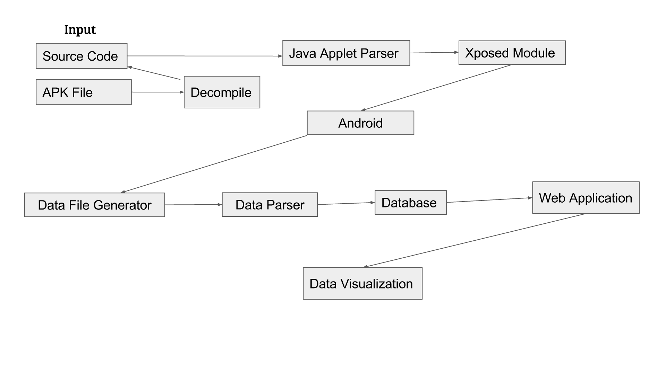

# Technologies Used

Below are the technologies currently used in Android Performance Evaluator.

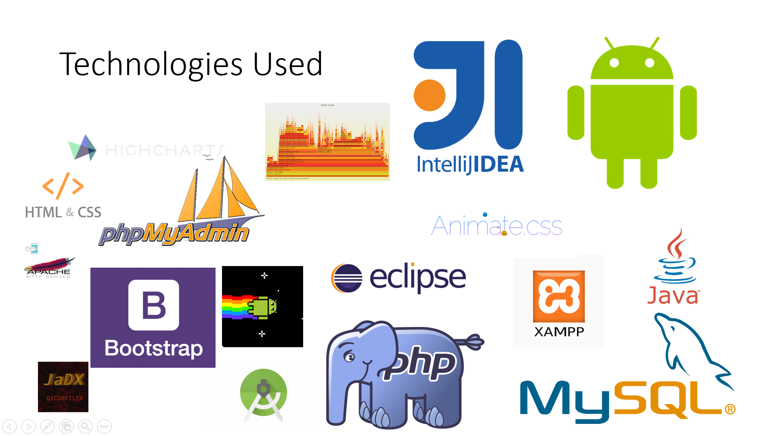

# Parser Components

# Before anything else, once launching the Java Applet Parser, the user is prompted to log in as shown below in Figure 0. The user will log in and in order to authenticate the user, it will call the membership database class in order to verify. The passwords are hashed with a custom MD5 function and stored in the database, so the Java Applet Parser will also hash the password with the custom MD5 function.

# C:\Users\kim\Documents\School\Spring Semster Junior Year\Software Engineering\Screen Shot 2016-04-08 at 2.06.22 PM.png

# Fig 0) File Explorer in choosing the apk or source code

# Once a user has been authenticated, the Java Applet Parser takes in either source code or an apk as input. If the input is an apk, it will decompile said apk and parse its source code. An apk or source code directory can be selected through the file explorer after hitting the “select file” button as shown in Figure 1.

# C:\Users\kim\Documents\School\Spring Semster Junior Year\Software Engineering\Screen Shot 2016-04-08 at 2.06.55 PM.png

# Fig 1) File Explorer in choosing the apk or source code

# Once the desired file has been selected, a SDK version and any external jar files that are required. Then it will begin the automatic parsing process once pushing “parse” as shown in Figure 2. Java Applet Parser will pull the package name, methods, parent classes, parameters, etc. for each method and will output that into a source file to be parsed by ModuleBuilder.

# C:\Users\kim\Documents\School\Spring Semster Junior Year\Software Engineering\Screen Shot 2016-04-08 at 2.30.24 PM.png

# Fig 2) Parsing demonstration with output from the terminal

# Android Components

# The ModuleBuilder from the Java Applet Parser will be then generate an Xposed module as shown in Figure 3.

# 

# Figure 3) Xposed Module code

# The Xposed module hooks methods based on the app you are analyzing. When a hooked method is executed, Xposed will record the start and exit time of the method in order to calculate the full execution time. Thankfully, the user will not have to touch the code, as it is automatically installed in an existing machine. Then the app will be analyzed to collect data. Once the user is done with collecting data, there will be a button on the java applet where the user can press to “Send Data”. The user then will be able to decided whether to cancel and scrap the trace data, or push it onto the database. These two options can be seen as seen in Figure 3.5. The user just needs to input the application name and their username again to get it set and working.

# https://scontent-iad3-1.xx.fbcdn.net/hphotos-xaf1/v/t35.0-12/13010171_10209524587454310_194317964_o.png?oh=d2e66fc7420b24463130997766e0752b&oe=570EAA40

# Figure 3) Data Sending window

# From this point on, the user must log into the webapp in order to access and visualize the data.

# Web Application Components

# The dataBaseListener, upon upload of this output, will add it to our database to be represented on the website, and organize it to the required tables. From this point, the user will move onto the website application. First, the user will be prompted to login to authenticate the user’s application and traces as shown in Figure 4.

# 

# Figure 4) Login Screen for the User

This will guide the user to the homepage screen where they have the option to navigate through their projects that they have current traces for as shown in Figure 5.

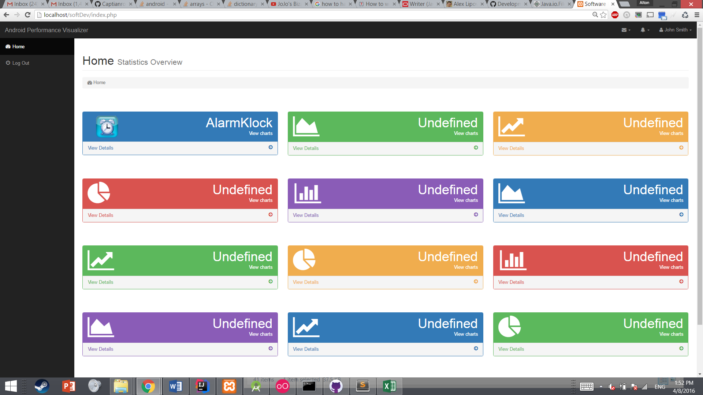

# Figure 5) Home page with options for the user.

When choosing the option, the user will be able to select from multiple traces that they may have on the database. Once choosing a specific trace, the user will be shown the data for their trace as shown in the highcharts below.

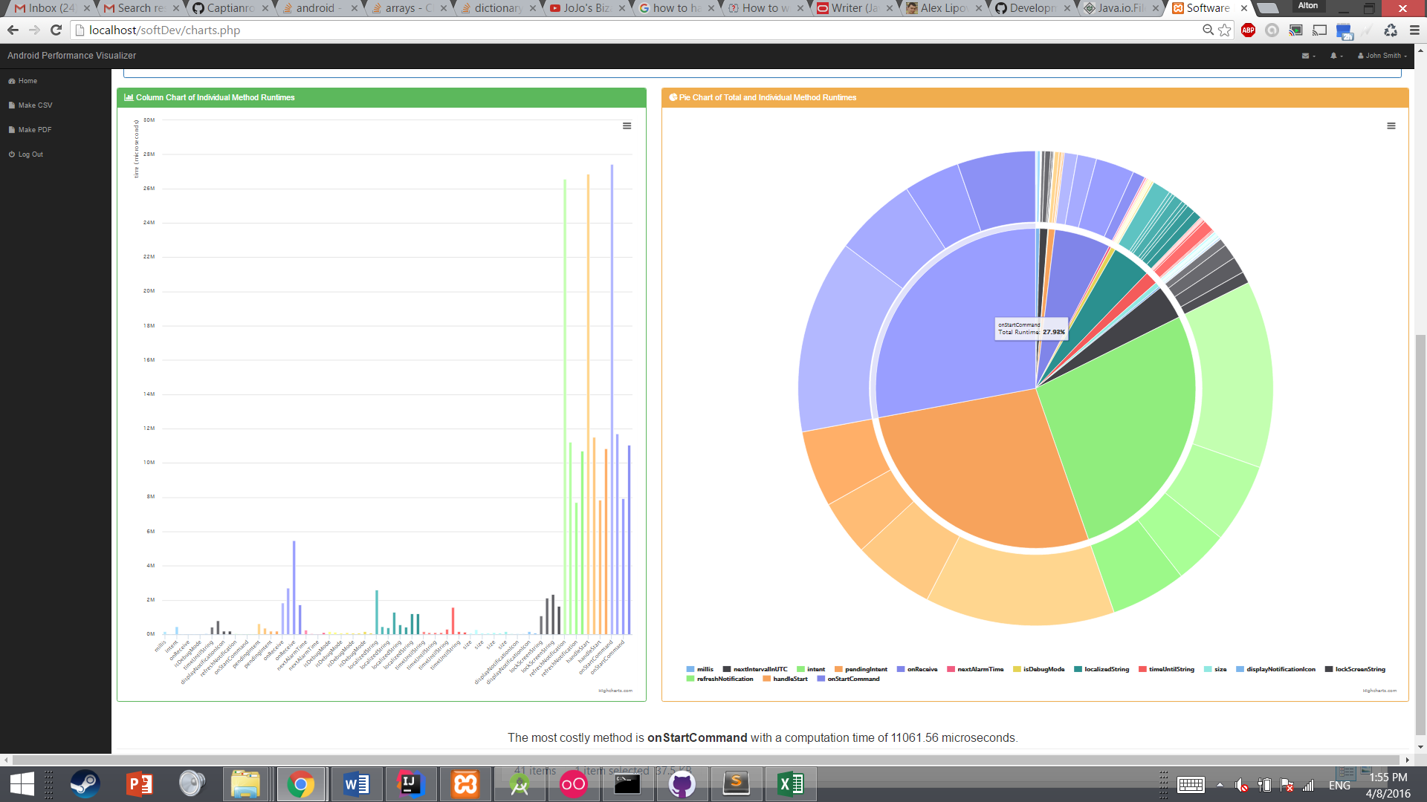

# Figure 6) Example of Data Visualization

# Database Model

Here is the current planned layout of the database. Each user logged in will be have their own set of applications and traces that are accessible to only them.

Holds

Membership

**Entites:**

Membership(username, id, password)

Users( username, application_name)

Applications(application_name, traceId)

Data(traceId, methodName, startTime,endTime

Users

Has

Applications

contains

data

# Database Definitions

|  |  |  |  |  |  |  |  |  |  |
| --- | --- | --- | --- | --- | --- | --- | --- | --- | --- |
| ***Entity Name*** | ***Entity Description*** | ***Column Name*** | ***Column Description*** |  | ***Data Type*** | ***Length*** | ***Primary Key*** | ***Nullable*** | ***Unique*** |
| Application | An application is the app the user is analyzing. | id | Auto-incrementing primary key. |  | integer | 11 | TRUE | FALSE | TRUE |
| username | User's username. |  | varchar | 40 | FALSE | FALSE | FALSE |
| application | The application a given user has analyzed. |  | varchar | 40 | FALSE | TRUE | FALSE |
| Data | Data contains information from the app analysis. | id | Auto-incrementing primary key. |  | integer | 11 | TRUE | FALSE | TRUE |
| traceId | Indicates the trace number, the user, and the application |  | varchar | 40 | FALSE | FALSE | FALSE |
| methodName | The name of the method. |  | varchar | 40 | FALSE | FALSE | FALSE |
| timeStart | The time at which the method began execution. |  | varchar | 40 | FALSE | FALSE | FALSE |
| timeEnd | The time at which the method ended execution. |  | varchar | 40 | FALSE | FALSE | FALSE |
| Traces | A trace is an analysis of a given app. There can be multiple traces for each app with respect to a given user. | id | Auto-incrementing primary key. |  | integer | 11 | TRUE | FALSE | TRUE |
| username | The user owning the trace. |  | varchar | 40 | FALSE | FALSE | FALSE |
| application | The application the user analyzed. |  | varchar | 40 | FALSE | TRUE | FALSE |
| traceId | unique id for the a trace |  | varchar | 40 | FALSE | TRUE | FALSE |
| Users | A user has analyzed one or more apps one or more times and signs in to view the data collected from his/her analysis. | id | Auto-incrementing primary key. |  | integer | 11 | TRUE | FALSE | FALSE |
| username | User's username. |  | varchar | 15 | FALSE | FALSE | FALSE |
| password | User's encrypted password. |  | varchar | 41 | FALSE | FALSE | FALSE |

# Sequence Diagram

# https://www.gliffy.com/go/publish/image/10396331/L.png

# Above is the sequence diagram that shows a more intricate flow of data for our application. It is a very one-directional flow of data, as there is no need for the android phone to communicate back with the java applet until the data needs to be collected. It can be seen that much of the application can be split into separate independent components that rely on each other’s output, but are not specifically dependent on the components themselves. Merely zoom in to the png to see more details or go to <https://www.gliffy.com/go/publish/image/10396331/L.png> for a more detailed image.

# Class Diagrams

# Java Component

# The Android component of the class diagram is also integrated as it is very closely tied to the flow of data of the java parser, since the java parser is the one to automatically upload it into the emulator. The main driving program is the Parser class, with it using and extending multiple other classes to successfully parse through source code, generate a valid Xposed module, and automatically deploying it onto the android phone connected. This includes the GUI and the user input.

# C:\Users\kim\Documents\School\Spring Semster Junior Year\Software Engineering\L.png

# We show the following connection between all the classes in the class diagram for the java applet as shown above. Merely zoom in to the png to see more details or go to <https://www.gliffy.com/go/publish/image/10384529/L.png> for a more detailed image.

# Web Application Deployment Diagram

# Although a class diagram may show the more intricate details of the web application, there is too many libraries and files that it would be too difficult to put on this document. However, the deployment diagram for the web application should cover the basic structure we followed in organizing the web application. A larger version is available at <https://www.gliffy.com/go/publish/image/10398685/L.png>

# https://www.gliffy.com/go/publish/image/10398685/L.png

# As seen through the deployment diagram, much of the web application is focused on the user client side. This allows us to create more personalized webpages for each different users. This may be moved to the server side if this causes any slowdowns on the client’s side.

# Limitations

# The parser does not analyze methods declared in an object instantiated within a method.

# We have noticed that decompiled APKs produce obfuscated classes and rename anonymous classes in ways that Xposed is unable to understand. The prevents us from analyzing decompiled APKs at this time.

# Currently, the module is unable to analyze classes in nested packages. Fixing this issue is our top priority.